**Table of content**

* **Parametric and nonparametric tests**
* **T-test**
* **Z-test and score**
* **Chi-square**
* **Residual**

**Parametric and nonparametric tests**

**Parametric and nonparametric** methodologies refer to those in which a set of data has a normal vs. a non-normal distribution, respectively. **Parametric tests** make certain assumptions about a data set; namely, that the data are drawn from a population with a specific (normal) distribution

**Parametric tests** assume underlying statistical distributions **in the** data. ...**Nonparametric tests** do not rely on any distribution. They can thus be applied even if **parametric** conditions of validity are not met. **Parametric tests** often have **nonparametric** equivalents.

How do you know if data is parametric or nonparametric?

**If** the mean more accurately represents the center of the distribution of your **data**, and your sample size is large enough, use a **parametric test**. **If** the median more accurately represents the center of the distribution of your **data**, use a **nonparametric test** even **if** you have a large sample size.

**Is Z test parametric or nonparametric?**

It usually means that you know the population data does not have a normal distribution. ... If your data isn't normally distributed, you can't run an ANOVA, but you can run the **nonparametric** alternative–the Kruskal-Wallis **test**. If at all possible, you should us **parametric tests**, as they tend to be more accurate

**Is Chi square a parametric test?**

The **Chi**-**square test** is a non-**parametric** statistic, also called a distribution free **test**. Non-**parametric tests** should be used when any one of the following conditions pertains to the data: The level of measurement of all the variables is nominal or ordinal

**Hypothesis Tests of the Mean and Median**

|  |  |
| --- | --- |
| **Parametric tests (means)** | **Nonparametric tests (medians)** |
| 1-sample t test | 1-sample Sign, 1-sample Wilcoxon |
| 2-sample t test | Mann-Whitney test |
| One-Way ANOVA | Kruskal-Wallis, Mood’s median test |
| Factorial DOE with one factor and one blocking variable | Friedman test |

## Reasons to Use Parametric Tests

**Reason 1: Parametric tests can perform well with skewed and nonnormal distributions**

This may be a surprise but parametric tests can perform well with continuous data that are nonnormal if you satisfy the sample size guidelines in the table below. These guidelines are based on simulation studies conducted by statisticians here at Minitab.

|  |  |
| --- | --- |
| **Parametric analyses** | **Sample size guidelines for nonnormal data** |
| 1-sample t test | Greater than 20 |
| 2-sample t test | Each group should be greater than 15 |
| One-Way ANOVA | * If you have 2-9 groups, each group should be greater than 15. * If you have 10-12 groups, each group should be greater than 20. |

**Reason 2: Parametric tests can perform well when the spread of each group is different**

While nonparametric tests don’t assume that your data follow a normal distribution, they do have other assumptions that can be hard to meet.

For nonparametric tests that compare groups, a common assumption is that the data for all groups must have the same spread (dispersion). If your groups have a different spread, the nonparametric tests might not provide valid results.

On the other hand, if you use the 2-sample t test or One-Way ANOVA, you can simply go to the **Options** subdialog and uncheck *Assume equal variances*. Voilà, you’re good to go even when the groups have different spreads!

**Reason 3: Statistical power**

Parametric tests usually have more statistical power than nonparametric tests. Thus, you are more likely to detect a significant effect when one truly exists.

**Reasons to Use Nonparametric Tests**

**Reason 1: Your area of study is better represented by the median**

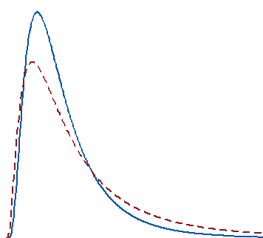This is my favorite reason to use a nonparametric test and the one that isn’t mentioned often enough! The fact that you *can* perform a parametric test with nonnormal data doesn’t imply that the mean is the best measure of the central tendency for your data.

For example, the center of a skewed distribution, like income, can be better measured by the median where 50% are above the median and 50% are below. If you add a few billionaires to a sample, the mathematical mean increases greatly even though the income for the typical person doesn’t change.

When your distribution is skewed enough, the mean is strongly affected by changes far out in the distribution’s tail whereas the median continues to more closely reflect the center of the distribution. For these two distributions, a random sample of 100 from each distribution produces means that are significantly different, but medians that are not significantly different.

Two other blog posts illustrate this point well:

* Using the Mean in Data Analysis: It’s Not Always a Slam-Dunk
* The Non-parametric Economy: What Does Average Actually Mean?

**Reason 2: You have a very small sample size**

If you don’t meet the sample size guidelines for the parametric tests and you are not confident that you have normally distributed data, you should use a nonparametric test. When you have a really small sample, you might not even be able to ascertain the distribution of your data because the distribution tests will lack sufficient power to provide meaningful results.

In this scenario, you’re in a tough spot with no valid alternative. Nonparametric tests have less power to begin with and it’s a double whammy when you add a small sample size on top of that!

**Reason 3: You have ordinal data, ranked data, or outliers that you can’t remove**

Typical parametric tests can only assess continuous data and the results can be significantly affected by outliers. Conversely, some nonparametric tests can handle ordinal data, ranked data, and not be seriously affected by outliers. Be sure to check the assumptions for the nonparametric test because each one has its own data requirements.

**T-test**

The independent-samples t-test (or independent t-test, for short) compares the means between two unrelated groups on the same continuous, dependent variable.

For example, you could use an independent t-test to understand whether first year graduate salaries differed based on gender (i.e., your dependent variable would be "first year graduate salaries" and your independent variable would be "gender", which has two groups: "male" and "female").

Alternately, you could use an independent t-test to understand whether there is a difference in test anxiety based on educational level (i.e., your dependent variable would be "test anxiety" and your independent variable would be "educational level", which has two groups: "undergraduates" and "postgraduates").

**Hypotheses**

The null hypothesis (H0) and alternative hypothesis (H1) of the Independent Samples t Test can be expressed in two different but equivalent ways:

H0: µ1 = µ2 ("the two population means are equal")

H1: µ1 ≠ µ2 ("the two population means are not equal")

OR

H0: µ1 - µ2 = 0 ("the difference between the two population means is equal to 0")

H1: µ1 - µ2 ≠ 0 ("the difference between the two population means is not 0")

where µ1 and µ2 are the population means for group 1 and group 2, respectively. Notice that the second set of hypotheses can be derived from the first set by simply subtracting µ2 from both sides of the equation.

* Click **Analyze > Compare Means > Independent-Samples T Test...** on the top menu, as shown below:

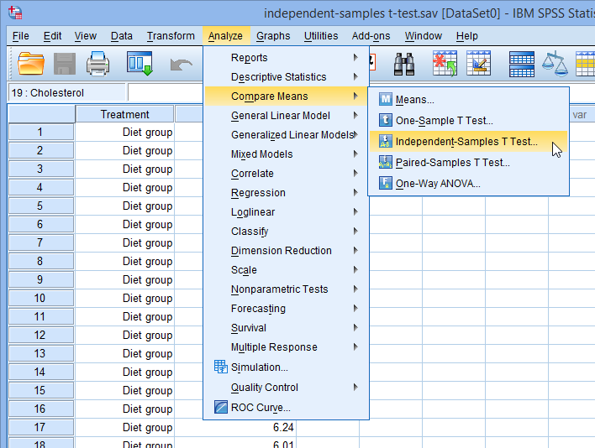

You will be presented with the **Independent-Samples T Test** dialogue box, as shown below:

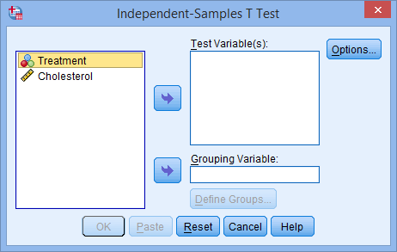

* Transfer the dependent variable, Cholesterol, into the Test Variable(s): box, and transfer the independent variable, Treatment, into the Grouping Variable: box, by highlighting the relevant variables and pressing the SPSS Right Arrow Button buttons. You will end up with the following screen:

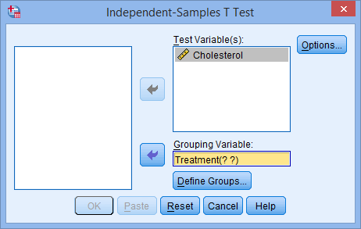

* You then need to define the groups (treatments). Click on the Define Options Button button. You will be presented with the **Define Groups**dialogue box, as shown below:

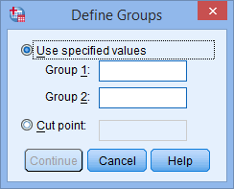

* Enter "**1**" into the Group 1: box and enter "**2**" into the Group 2: box. Remember that we labelled the **Diet Treatment** group as **1** and the **Exercise Treatment** group as **2**.

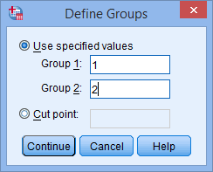

**Note:** If you have more than 2 treatment groups in your study (e.g., 3 groups: **diet**, **exercise** and **drug** treatment groups), but only wanted to compared two (e.g., the **diet** and **drug** treatment groups), you could type in **1** to Group 1: box and **3** to Group 2:box (i.e., if you wished to compare the diet with drug treatment).

* Click the https://statistics.laerd.com/spss-tutorials/img/istt/continue-button.png button.
* If you need to change the confidence level limits or change how to exclude cases, click the Options Button button. You will be presented with the following:

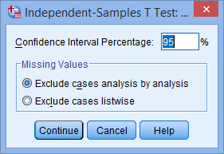

* Click the https://statistics.laerd.com/spss-tutorials/img/istt/continue-button.png button. You will be returned to the **Independent-Samples T Test** dialogue box.
* Click the https://statistics.laerd.com/spss-tutorials/img/istt/ok-button.png button.

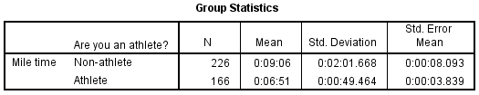

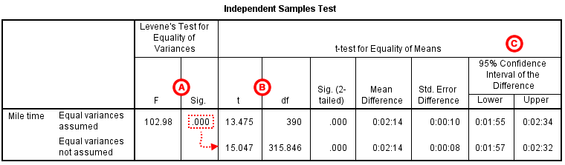

**Z-test and score**

What is a Z-Test?

A z-test is a statistical test used to determine whether two population means are different when the variances are known and the sample size is large. The test statistic is assumed to have a normal distribution, and nuisance parameters such as standard deviation should be known in order for an accurate z-test to be performed.

Understanding Z-Test

A one-sample location test, two-sample location test, paired difference test and maximum likelihood estimate are examples of tests that can be conducted as z-tests. Z-tests are closely related to t-tests, but t-tests are best performed when an experiment has a small sample size. Also, t-tests assume the standard deviation is unknown, while z-tests assume it is known. If the standard deviation of the population is unknown, the assumption of the sample variance equaling the population variance is made.

Hypothesis Test

The z-test is also a hypothesis test in which the z-statistic follows a normal distribution. The z-test is best used for greater than 30 samples because, under the central limit theorem, as the number of samples gets larger, the samples are considered to be approximately normally distributed. When conducting a z-test, the null and alternative hypotheses, alpha and z-score should be stated. Next, the test statistic should be calculated, and the results and conclusion stated.

KEY TAKEAWAYS

A Z-test is a statistical test to determine whether two population means are different when the variances are known and the sample size is large.

It can used to test hypotheses in which the z-test follows a normal distribution.

One-Sample Z-Test Example

For example, assume an investor wishes to test whether the average daily return of a stock is greater than 1%. A simple random sample of 50 returns is calculated and has an average of 2%. Assume the standard deviation of the returns is 2.50%. Therefore, the null hypothesis is when the average, or mean, is equal to 3%.

Conversely, the alternative hypothesis is whether the mean return is greater than 3%. Assume an alpha of 0.05% is selected with a two-tailed test. Consequently, there is 0.025% of the samples in each tail, and the alpha has a critical value of 1.96 or -1.96. If the value of z is greater than 1.96 or less than -1.96, the null hypothesis is rejected.

The value for z is calculated by subtracting the value of the average daily return selected for the test, or 1% in this case, from the observed average of the samples. Next, divide the resulting value by the standard deviation divided by the square root of the number of observed values. Therefore, the test statistic is calculated to be 2.83, or (0.02 - 0.01) / (0.025 / (50)^(1/2)). The investor rejects the null hypothesis since z is greater than 1.96, and concludes that the average daily return is greater than 1%.

**Analyze your data**

1. Click Analyze, Descriptive Statistics and then Descriptives. A Descriptives box will appear.
2. Move your variable to the Variable box by clicking on it to highlight it and clicking on the arrow button.
3. Check the “Save standard values as variables,” option by clicking in the corresponding box.
4. Click OK and wait a few seconds for processing. The output will appear.
5. You might want to write down the mean in the output file. You can optionally save the output to a meaningful place with a meaningful name. SPSS should give the output file a .spo extension.
6. Your z-scores will be in your data file. Go back to the data file and save it again, now that it has been modified by SPSS. The data file will still have a .sav extension.

**Interpret your results**

1. Look in your data file, NOT your output file.
2. Your z-scores will appear in a second column of data with the letter ‘z’ in front of its name. Each data point that you entered in the column on the left will have a corresponding z-score printed in the column just next to it.
3. If a z-score is positive, its’ corresponding raw score is above (greater than) the mean. If a z-score is negative, its’ corresponding raw score is below (less than) the mean.
4. The absolute value of a z-score will tell you how far away the score is from the mean in standard deviation units. 95% of scores are going to be no more than 2 standard deviation units away from the mean. That means that most scores will fall between z=-2 to z=+2. However, some scores will be greater than the absolute value of 2. You can interpret these scores to be very far from the mean.
5. If A z-score…

* Has a value of 0, it is equal to the group mean.
* Is positive, it is above the group mean.
* Is negative, it is below the group mean.
* Is equal to +1, it is 1 Standard Deviation above the mean.
* Is equal to +2, it is 2 Standard Deviations above the mean.
* Is equal to -1, it is 1 Standard Deviation below the mean.
* Is equal to -2, it is 2 Standard Deviations below the mean.

**Chi-square**

The **Chi**-**Square Test** of Independence determines whether there is an association between categorical variables (i.e., whether the variables are independent or related). It is a nonparametric **test**. This **test** is also known as: **Chi**-**Square Test** of Association.

Data Requirements

Your data must meet the following requirements:

Two categorical variables.

Two or more categories (groups) for each variable.

Independence of observations.

There is no relationship between the subjects in each group.

The categorical variables are not "paired" in any way (e.g. pre-test/post-test observations).

Relatively large sample size.

Expected frequencies for each cell are at least 1.

Expected frequencies should be at least 5 for the majority (80%) of the cells.

### IF YOU HAVE THE RAW DATA (EACH ROW IS A SUBJECT):

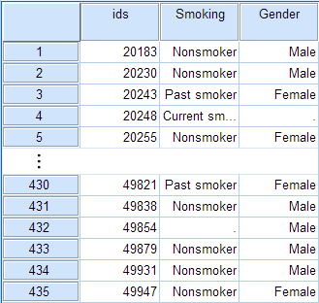

The Chi-Square Test of Independence is an option within the Crosstabs procedure. Recall that the Crosstabs procedure creates a contingency table or two-way table, which summarizes the distribution of two categorical variables.

To create a crosstab and perform a chi-square test of independence, click Analyze > Descriptive Statistics > Crosstabs.

* Click **Analyze > Descriptives Statistics > Crosstabs...** on the top menu, as shown below:

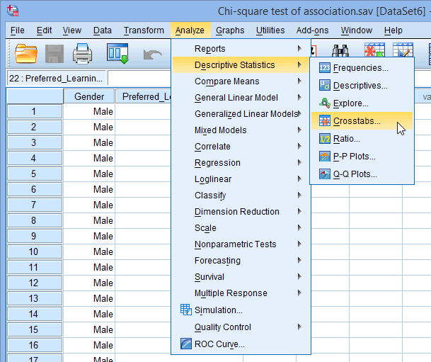

* You will be presented with the following **Crosstabs** dialogue box:

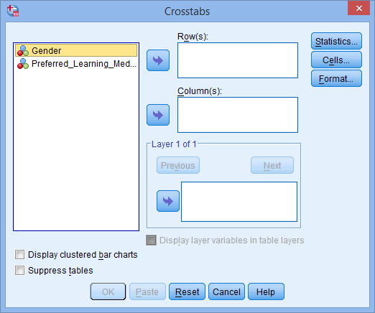

* Transfer one of the variables into the Row(s): box and the other variable into the Column(s): box. In our example, we will transfer the Gender variable into the Row(s): box and Preferred_Learning_Medium into the Column(s): box. There are two ways to do this. You can either: (1) highlight the variable with your mouse and then use the relevant SPSS Right Arrow Button buttons to transfer the variables; or (2) drag-and-drop the variables. How do you know which variable goes in the row or column box? There is no right or wrong way. It will depend on how you want to present your data.

If you want to display clustered bar charts (recommended), make sure that Display clustered bar charts checkbox is ticked.

You will end up with a screen similar to the one below:

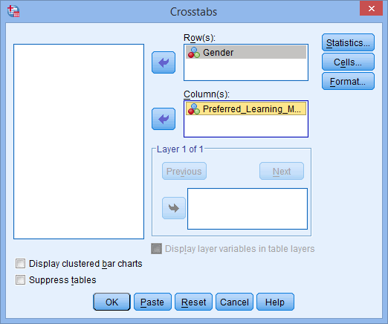

* Click on the SPSS Statistics Button button. You will be presented with the following **Crosstabs: Statistics** dialogue box:

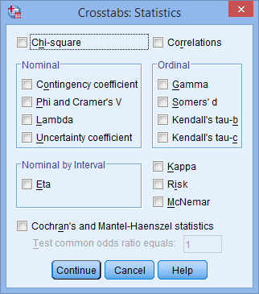

* Select the Chi-square and Phi and Cramer's V options, as shown below:

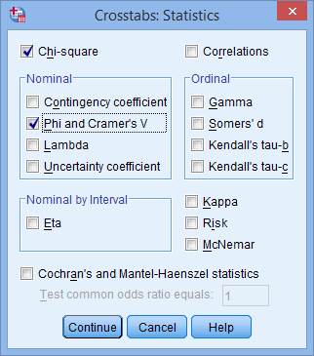

* Click the SPSS Continue Button button.
* Click the SPSS Cells Button button. You will be presented with the following **Crosstabs: Cell Display** dialogue box:

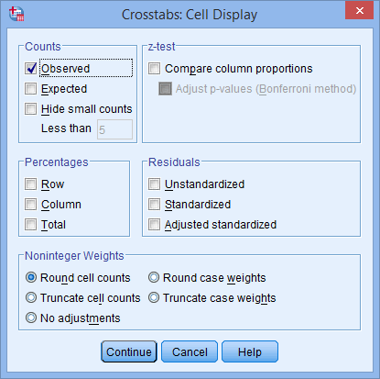

* Select Observed from the –Counts– area, and Row, Column and Total from the –Percentages– area, as shown below:

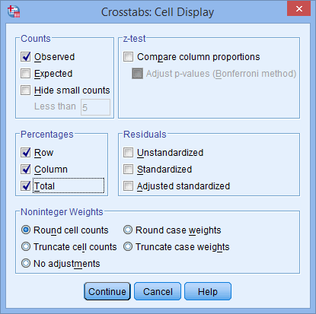

* Click the SPSS Continue Button button.
* Click the SPSS Format Button button.

**Note:** This next option is only really useful if you have more than two categories in one of your variables, but we will show it here in case you have. If you don't, you can skip to STEP 12.

* You will be presented with the following:

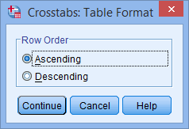

This option allows you to change the order of the values to either ascending or descending.

* Once you have made your choice, click the SPSS Continue Button button.
* Click the https://statistics.laerd.com/spss-tutorials/img/cstfa/ok-button.png button to generate your output.

**Residual**

The difference between the observed value of the dependent variable (y) and the predicted value (ŷ) is called the **residual** (e). Each data point has one **residual**. Both the sum and the mean of the **residuals** are equal to zero.

A **residual plot** is a graph that shows the **residuals** on the vertical axis and the independent variable on the horizontal axis. ... The other **plot** patterns are non-random (U-shaped and inverted U), suggesting a better fit for a non-linear model.

Residual score

Each person's **residual score** is the difference between their predicted **score**(determined by the values of the IV's) and the actual observed **score** of your DV by that individual. That "left-over" **value** is a **residual**.

**Test Procedure in SPSS Statistics**

1. Click Analyze > Regression > Linear... on the top menu, as shown below: ...
2. Transfer the independent variable, Income, into the Independent(s): box and the dependent variable, Price, into the Dependent: box.
3. What does it mean when a residual is positive?
4. The **residual** is the actual (observed) value minus the predicted value. If you have a negative value for a **residual** it **means** the actual value was LESS than the predicted value. The person actually **did** worse than you predicted. ... Above the line, you UNDER-predicted, so you have a **positive residual**

What does a good residual plot look like?

These problems are more easily seen with a **residual plot** than by **looking** at a **plot**of the original data set. Ideally, **residual** values **should** be equally and randomly spaced around the horizontal axis. If your **plot looks like** any of the following images, then your data set is probably not a **good** fit for regression.

What do standardized residuals tell us?

The **standardized residual** is a measure of the strength of the difference between observed and expected values. It's a measure of how significant your cells **are** to the chi-square value.

Why do residuals sum to zero?

The **sum** of the **residuals** always equals **zero** (assuming that your line **is** actually the line of “best fit.” ... The mean of **residuals is** also equal to **zero**, as the mean = the**sum** of the **residuals** / the number of items. The **sum is zero**, so **0**/n will always equal **zero**.